Accessibility Guide for The Curious Eatery
feast@thecuriouseatery.co.uk, 01622 299359, www.thecuriouseatery.co.uk
Contact for accessibility enquiries; Lesley Parry and Nicole
Welcome
The Curious Eatery is a family run restaurant. We serve up classic dishes with a curious twist. We offer tea, coffee, cake and sausage rolls throughout the day, lunches, dinner and breakfast on a Friday and Saturday and a traditional Roast on Sundays. We are a friendly and relaxed eatery that serve high quality fresh food made from local produce.
We welcome families and can provide high chairs, we also have baby changing facilities. All dogs are welcome and water bowls can be provided. We also cater for a wide variety of diets, please make us aware of any special requirements.
At a Glance
Level Access
- There is level access from the main entrance to;
Downstairs dining table
Accessible Toilet
Garden tables

Hearing
- There is background music in the eatery
Visual
- The venue has low lighting during dinner service
- We have the menu in large print available on request

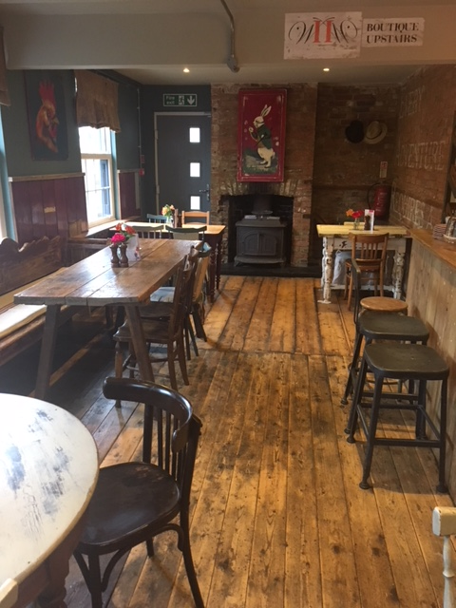
Part of the dining area of the restaurant
Getting here
The Curious Eatery, Albion Inn, 1 Church Street, Boughton Monchelsea, Maidstone, ME17 4HW
Travel by public transport
- You can get to the eatery by bus.
- The bus stop is situated in the car park of the eatery
- No 59 runs from Kings street in the centre of Maidstone, please click on link to view all stops and times. https://bustimes.org/services/59-maidstone-boughton-monchelsea-grafty-green
- A taxi service is also available via black cab from Maidstone town centre or by calling Saphire Cars on 01622 663000 (do not have wheelchair accessible vehicles) or Express Taxis on 01622 222222 (who do have wheelchair accessible vehicles).
Parking
- We have a small car park which is half tarmac and half shingle, we do not have a specific designated disabled parking as of yet. There is also on street parking on Green lane and Church Street.
- There is level access from the car park to the main entrance
- Parking is free
- There is lighting during darkness hours

Arrival
Path to main entrance
- From the street and the car tarmacked area of the car park, there is level access

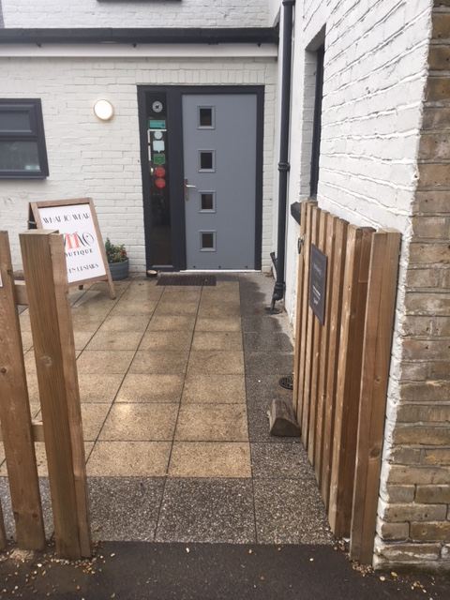
Main Entrance
- The main entrance has level access
- The main door is 850mm wide
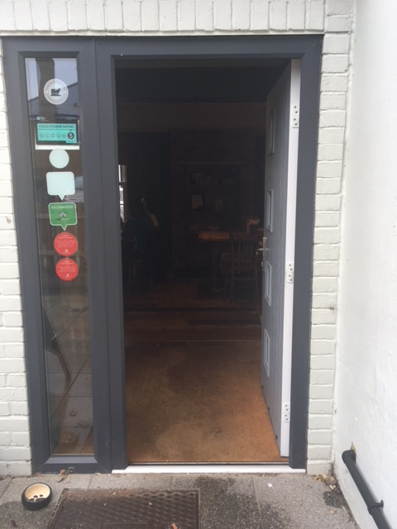
Restaurant front door
Getting around inside
Visual impairment – general information
- We have high colour contrast between most walls and doorframes
- Some parts of the venue have low lighting in the evening service.
Lift
- We do not have a lift to the upper floor function room, however we have seating on the lower floor.
Accessible toilet
- There is a toilet for disabled guests
- The toilet door is 850mm wide
- The direction of transfer onto the toilet is
- There are 240mm on each side of the toilet. There is 1200mm in front of the toilet. The toilet seat is 400mm high. The toilets have handrails and an emergency chord.

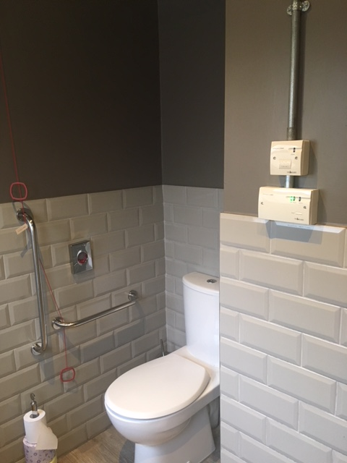
Disabled toilet

